Promise method

## Promise.all

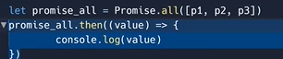

## Promise.allSettled

Intitial js

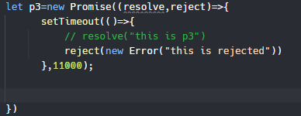

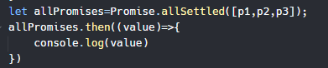

Result on console

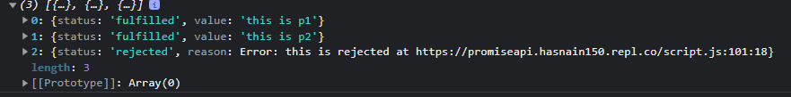

## Promise.race

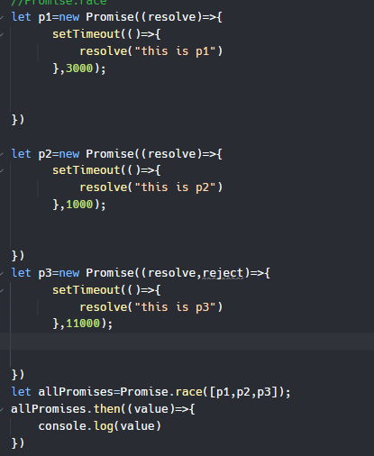



Jo promise sub se pehlay full filled hoga uss ke value aajai gi

## Promise.any

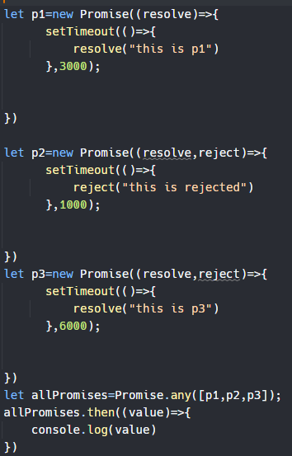

Jo sub se pehlay resolve hoga inthis case , p2 rejected hiai lkin least time le rha hai prr value p1 ke show ho gi

## Promise.resolve and Promise.reject()

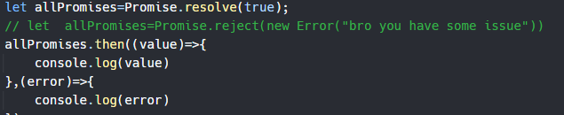

<https://youtu.be/xJQemfYXEf8>

<https://replit.com/@Hasnain150/promiseApi#script.js>